|  |
| --- |
| **苏州中德睿博智能科技有限公司** |
| 时间同步器规格书 |
| RS-TS5时间同步器 |

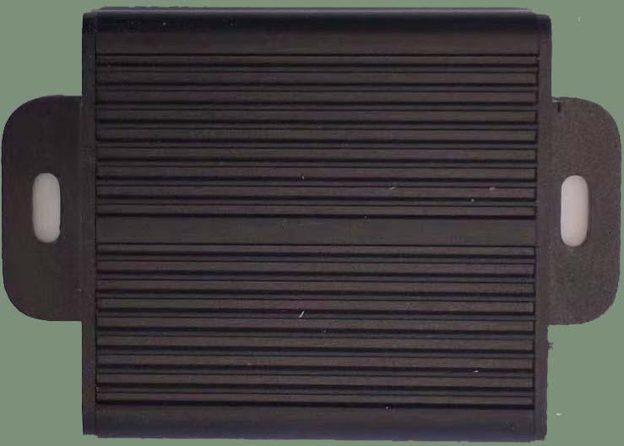

|  |  |  |  |  |  |  |  |  |  |  |  |  |  |  |  |  |  |  |  |  |  |  |  |  |  |  |  |  |  |  |  |  |  |  |  |  |  |  |  |  |  |  |  |  |  |  |  |  |  |  |  |  |  |  |  |  |  |  |  |  |  |  |  |  |  |  |  |  |  |  |  |  |  |  |  |  |  |  |  |  |  |  |  |  |  |  |  |  |  |  |  |  |  |  |  |  |  |  |  |  |  |  |  |  |  |  |  |  |  |  |  |  |  |  |  |  |  |  |  |  |  |  |  |  |  |  |  |  |  |  |  |  |  |  |  |  |  |  |  |  |  |  |  |  |
| --- | --- | --- | --- | --- | --- | --- | --- | --- | --- | --- | --- | --- | --- | --- | --- | --- | --- | --- | --- | --- | --- | --- | --- | --- | --- | --- | --- | --- | --- | --- | --- | --- | --- | --- | --- | --- | --- | --- | --- | --- | --- | --- | --- | --- | --- | --- | --- | --- | --- | --- | --- | --- | --- | --- | --- | --- | --- | --- | --- | --- | --- | --- | --- | --- | --- | --- | --- | --- | --- | --- | --- | --- | --- | --- | --- | --- | --- | --- | --- | --- | --- | --- | --- | --- | --- | --- | --- | --- | --- | --- | --- | --- | --- | --- | --- | --- | --- | --- | --- | --- | --- | --- | --- | --- | --- | --- | --- | --- | --- | --- | --- | --- | --- | --- | --- | --- | --- | --- | --- | --- | --- | --- | --- | --- | --- | --- | --- | --- | --- | --- | --- | --- | --- | --- | --- | --- | --- | --- | --- | --- | --- | --- | --- | --- |
| 目录  1. 产品名称及管理号 1  2.产品简介 1  2.1.功能特点 1  2.2.模块系统参数 1  2.3.接口描述 2  2.4.引脚定义 2  2.5.电气参数 2  3. 典型应用 3  4. 机械尺寸 3  5. 交付清单 3  6. 重要说明 3  7. 修订历史 3 产品名称及管理号 -中文名称：时间同步器  -英文名称：Time Synchronizer  -内部型号：RS-TS5  -客户型号：RS-TS5 产品简介 RS-TS5可基于外部1PPS或者内部时钟，实现8通道的同步触发信号生成。8个通道之间、8个通道与外部1PPS之间的同步精度达到微秒级，当外部1PPS无效时，可自动切换为外部基准。8个通道参数可通过串口单独配置，配置参数包括输出频率、输出占空比和输出有效电平。 功能特点  * 同步精度高、同步延迟小 * 输入输出脉冲参数通串口可调 * 同时支持八路信号同步 * 同时支持内部、外部脉冲触发，无外部脉冲时自动切换内部脉冲触发 * 低频率误差，误差不大于10PPM * 同步精度小于5us  2.2. 模块系统参数  |  |  |  | | --- | --- | --- | | 参数名称 | 参数值 | 描述 | | 输入脉冲特性 | 输入脉冲范围 | 0~10hz | | 输入电平类型 | TTL电平（0-3.3V) | | 电平保持时间 | >1ms | | 输出脉冲特性 | 输出脉冲范围 | 1~4000hz | | 输出电平类型 | TTL电平（0-3.3V) | | 电平保持时间 | >250us | | 同步特性 | 输入-输出同步精度 | <5us | | 输出-输出同步精度 | <5us | | 内部频率稳定性 | ±10ppm | | 环境特性 | 工作温度范围 | -40℃~+85℃ | | 存储温度范围 | -45℃~+85℃ | | 湿度范围 | 0~95% | | 抗振动、抗冲击 | IEC 60068-2-6:2007  IEC 60068-2-27:2008 | | 防水防尘 | IP63 |  2.3. 接口描述  2.4. 引脚定义  |  |  |  |  | | --- | --- | --- | --- | | **引脚号** | **定义** | **输入/输出** | **描述** | | **1** | RESERV | IN | 内部保留 | | **2** | GND | OUT | 电源地 | | **3** | GND | OUT | 电源地 | | **4** | GND | OUT | 电源地 | | **5** | GND | OUT | 电源地 | | **6** | GND | OUT | 电源地 | | **7** | GND | OUT | 电源地 | | 8 | GND | OUT | 电源地 | | **9** | GND | OUT | 电源地 | | **10** | GND | OUT | 电源地 | | **11** | TXD | OUT | 参数配置串口发 | | **12** | GND | OUT | 电源地 | | **13** | 5V | IN | 电源正 | | **14** | RXD | IN | 参数配置串口收 | | **15** | CH1 | OUT | 同步输出1 | | **16** | CH2 | OUT | 同步输出2 | | **17** | CH3 | OUT | 同步输出3 | | **18** | CH4 | OUT | 同步输出4 | | **19** | CH5 | OUT | 同步输出5 | | **20** | CH6 | OUT | 同步输出6 | | **21** | CH7 | OUT | 同步输出7 | | **22** | CH8 | OUT | 同步输出8 | | **23** | PPS | IN | PPS输入 | | **24** | RESERV | OUT | 内部保留 |  2.5. 电气参数  * 供电电压：DC5V±5% * 整机功耗：<1W * 输出脉冲最大电流：<5MA * 测量状态平均电流：<80mA(5V供电)  典型应用  * 基于GNSS的1PPS的多频率信号生成； * 多传感器同步采集； * 多设备时间同步；  机械尺寸（单位：毫米） 结构尺寸：48*45*18.5 交付清单  1. 同步采集器盒子   2.外部连接线 重要声明 ⚫ 中德睿博保留对本说明书中所有内容的最终解释权及修改权。  ⚫ 由于随着产品的硬件及软件的不断改进，本说明书可能会有所更改，恕不另行告知，最终应以最新版的说明书为准。 修订历史  |  |  |  | | --- | --- | --- | | 版本 | 修订日期 | 修订说明 | | V1.0 | 2023.05.21 | 初始版本 | | V1.1 | 2023.08.16 | 修改外壳尺寸和接口 | |