|  |
| --- |
| **苏州中德睿博智能科技有限公司** |
| 组合导航及外同步模块规格书 |
| RS-INTS1组合导航及外同步模块 |

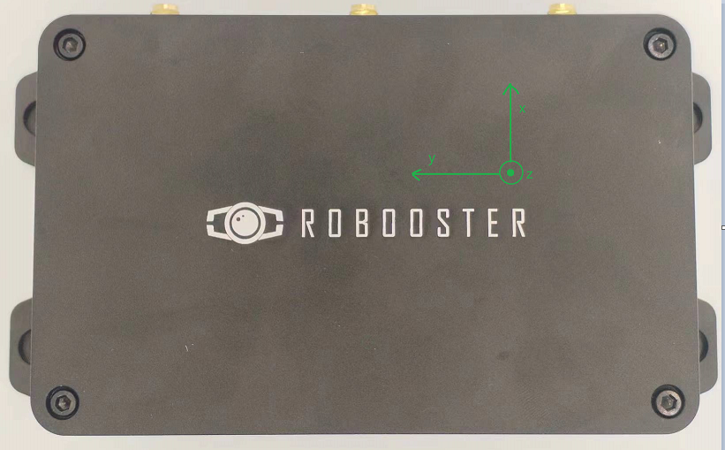

|  |  |  |  |  |  |  |  |  |  |  |  |  |  |  |  |  |  |  |  |  |  |  |  |  |  |  |  |  |  |  |  |  |  |  |  |  |  |  |  |  |  |  |  |  |  |  |  |  |  |  |  |  |  |  |  |  |  |  |  |  |  |  |  |  |  |  |  |  |  |  |  |  |  |  |  |  |  |  |  |  |  |  |  |  |  |  |  |  |  |  |  |  |  |  |  |  |  |  |  |  |  |  |  |  |  |  |  |  |  |  |  |  |  |  |  |  |  |  |  |  |  |  |  |  |  |  |  |  |  |  |  |  |  |  |  |  |  |  |  |  |  |  |  |  |  |  |  |  |  |  |  |  |  |  |  |  |  |  |  |  |  |  |  |  |  |  |  |  |  |  |  |  |  |  |  |  |  |  |  |  |  |  |  |  |  |  |  |  |  |  |
| --- | --- | --- | --- | --- | --- | --- | --- | --- | --- | --- | --- | --- | --- | --- | --- | --- | --- | --- | --- | --- | --- | --- | --- | --- | --- | --- | --- | --- | --- | --- | --- | --- | --- | --- | --- | --- | --- | --- | --- | --- | --- | --- | --- | --- | --- | --- | --- | --- | --- | --- | --- | --- | --- | --- | --- | --- | --- | --- | --- | --- | --- | --- | --- | --- | --- | --- | --- | --- | --- | --- | --- | --- | --- | --- | --- | --- | --- | --- | --- | --- | --- | --- | --- | --- | --- | --- | --- | --- | --- | --- | --- | --- | --- | --- | --- | --- | --- | --- | --- | --- | --- | --- | --- | --- | --- | --- | --- | --- | --- | --- | --- | --- | --- | --- | --- | --- | --- | --- | --- | --- | --- | --- | --- | --- | --- | --- | --- | --- | --- | --- | --- | --- | --- | --- | --- | --- | --- | --- | --- | --- | --- | --- | --- | --- | --- | --- | --- | --- | --- | --- | --- | --- | --- | --- | --- | --- | --- | --- | --- | --- | --- | --- | --- | --- | --- | --- | --- | --- | --- | --- | --- | --- | --- | --- | --- | --- | --- | --- | --- | --- | --- | --- | --- | --- | --- | --- | --- | --- | --- | --- |
| 目录  1. 产品名称及管理号 2  2.产品简介 2  2.1.功能特点 2  2.2.系统参数特性 3  2.3.传感器性能指标 3  2.4.接口描述 4  2.5.引脚定义 4  2.6.电气参数 5  2.7.系统框图 5  3. 典型应用 5  4. 机械尺寸 6  5. 交付清单 7  6. 重要说明 7  7. 修订历史 7 产品名称及管理号 -中文名称：组合导航及外同步模块  -英文名称：Integrated navigation and external synchronization module  -内部型号：RS-INTS1  -客户型号：RS-INTS1 产品简介 RS-INTS1内部集成双天线差分 GNSS 模块、3 轴陀螺、3 轴加速度计、3 轴磁强计以及气压计，内部传感器采样严格与 1PPS 同步，同时将 GNSS 的 1PPS 作为输入，可以根据用户配置的频率，生成并输出与 1PPS 同步的最多 6 路同步信号，用来给用户的其他设备提供触发信号，6 路同步信号的频率、占空比等均单独可配置。内部集成4G模块，与组合导航基站模块配对使用，上电自动与组合导航基站模块通信，获取RTK差分数据，实现上电即可高精度 RTK 定位。双天线差分 GNSS 模块同时可为用户提供高精度的方位输出。 功能特点 • 内部集成双天线差分GNSS模块  • 内部集成高性能MEMS-IMU  • 内部集成3轴磁强计和气压计  • 内部传感器数据采集完全与1PPS同步  • 6通道同步触发信号输出• 同步信号的频率、触发偏移、有效电平、占空比等参数可独立配置• 外部秒脉冲/内部秒脉冲模式  • 提供ROS驱动 2.2. 系统参数特性  |  |  |  | | --- | --- | --- | | 参数名称 | 参数值 | 描述 | | 输入脉冲特性 | 输入脉冲范围 | 0~10hz | | 输入电平类型 | TTL电平（0-3.3V) | | 电平保持时间 | >1ms | | 输出脉冲特性 | 输出脉冲范围 | 1~4000hz | | 输出电平类型 | TTL电平（0-3.3V) | | 电平保持时间 | >250us | | 同步特性 | 输入-输出同步精度 | <5us | | 输出-输出同步精度 | <5us | | 内部频率稳定性 | ±10ppm | | 环境特性 | 工作温度范围 | -40°~+85° | | 储存温度范围 | -40°~+85° | | 工作湿度范围 | 0~95% | | 抗振动、抗冲击 | IEC 60068-2-6:2007  IEC 60068-2-27:2008 | | 防水防尘 | IP63 |  2.3 传感器性能指标GNSS性能指标：  |  |  | | --- | --- | | 参数类型 | 参数值 | | 信号支持 | BD/GPS/GLONASS/GALILEO/QZSS | | 单点定位(RMS) | 平面：1.5m，高程：2.5m | | DGPS(RMS) | 平面：0.4m，高程：0.8m | | RTK(RMS) | 平面：0.8cm+1ppm，高程：1.5cm+1ppm | | 定向精度 (RMS) | 0.1°/1m 基线 | | 时间精度 (RMS) | 20ns | | 速度精度 (RMS) | 0.03m/s |  • 惯性测量单元性能指标：  |  |  | | --- | --- | | 参数类型 | 参数值 | | 陀螺量程 | ±300°/s | | 陀螺噪声 | 0.007 °/s | | 陀螺零偏不稳定性(Allan方差) | 1.64 °/h | | 陀螺噪声密度（noist density) | 0.0015°/s/ | | 陀螺角度随机游走误差(angle random walk) | 0.09°/ | | 加速度计量程 | ±6g | | 加速度计噪声 | 0.5mg | | 加速度计零偏不稳定性（Allan方差） | 0.01 mg | | 加速度计噪声密度（noist density) | 59.5ug/ | | 加速度计速度随机游走(velocity random walk) | 35.0mm/s/ | | 输出数据频率 | 200hz |  • 气压计性能指标：  |  |  | | --- | --- | | 参数类型 | 参数值 | | 分辨率 | 0.012 mbar | | 测量范围 | 10 到1200 mbar | | 输出数据频率 | 50hz |  • 地磁传感器性能指标：  |  |  | | --- | --- | | 参数类型 | 参数值 | | 测量范围 | -8.1gauss to 8.1gauss | | 分辨率 | 4.35 milli-gauss | | 灵敏度（增益） | 1370 LSb/gauss | | 直线性 | ±2 %FS | | 动态范围 | ±0.88-±8.1 gauss | | 输出数据频率 | 50hz |  2.4. 接口描述  2.5. 引脚定义  |  |  |  |  | | --- | --- | --- | --- | | 座子名称 | 引脚序号 | 引脚定义 | 说明 | | X1 | 1 | OUT5 | PWM输出 | | X1 | 2 | OUT4 | PWM输出 | | X1 | 3 | OUT3 | PWM输出 | | X1 | 4 | OUT2 | PWM输出 | | X1 | 5 | OUT1 | PWM输出 | | X1 | 6 | IN-PPS | PPS输入 | | X1 | 7 | GND | 电源地 | | X1 | 8 | GND | 电源地 | | X1 | 9 | GND | 电源地 | | X2 | 1 | RS485-B | 485接口 | | X2 | 2 | RS485-A | 485接口 | | X2 | 3 | GND | 电源地 | | X2 | 4 | RS232-TX | 232串口 | | X2 | 5 | RS232-RX | 232串口 | | X2 | 6 | GND | 电源地 | | X2 | 7 | OUT6 | PWM输出 | | X3 | 1 | DC12V | 输入电源 | | X3 | 2 | GND | 电源地 | | NET |  | 网络指示灯 | 指示网络 | | RTK |  | RTK定位指示灯 | 指示RTK定位 |  2.6. 电气参数 - 供电电压：DC5~12V±5%  - 整机功耗：<1W  - 输出脉冲最大电流：<5MA  - 测量状态平均电流：<100mA(12V供电) 2.7. 系统框图  典型应用 • 无人机  • 智能驾驶  • 割草机  • 精准农业 机械尺寸（单位：毫米）   图一：同步模块外形尺寸    图二：GPS天线  GPS天线外形尺寸：Ф27.3*58.6mm 交付清单  1. 组合导航同步模块一个   2.GPS天线二根(型号BT-560)  3.GPS天线延长线二根(长度一米)  4.4G天线一根(带延长线)  5.ROS驱动 重要声明 ⚫ 中德睿博保留对本说明书中所有内容的最终解释权及修改权。  ⚫ 由于随着产品的硬件及软件的不断改进，本说明书可能会有所更改，恕不另行告知，最终应以最新版的说明书为准。 修订历史  |  |  |  | | --- | --- | --- | | 版本 | 修订日期 | 修订说明 | | V1.0 | 2023.05.21 | 初始版本 | | V1.5 | 2023.08.10 | 修改外壳尺寸及接口定义 | |